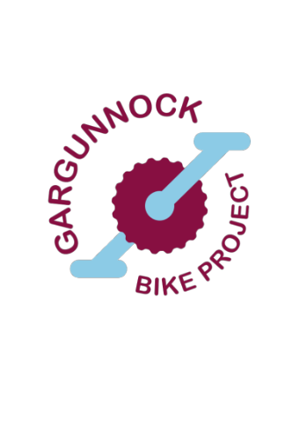
Gargunnock Bike Project: E-bike Loan Scheme Instructions for Users

Take this handout with you.
Please enjoy this E-bike and all the benefits it can bring to your cycling experience.

- You borrow this E-bike at your own responsibility.
- You are not covered for any personal injury or third-party liability.
- Please return the E-bike in the same condition it was in when you borrowed it.
- Lock up the bike and remove the computer if you leave it unattended.
- Ensure that no one under the age of 14 operates the bike (Highway Code).

Prior to the loan you (the cyclist) must have completed the following:
- Competency assessment with a Ride Leader.
- Equipment Loan Agreement with a member of Gargunnock Bike Project.

The loan period is a max of 30 days.

You should have the following equipment with the E-bike
- Keys for the battery and E-bike
- Helmet, if you want one
- Bike lock and key
- Puncture repair kit
- 2 Tyre levers
- Pump
- Multitool
- Battery charger and cable

Check the E-bike before you loan the E-bike
Do an ‘M’ check of the bike with the staff so the e-bike is safe to use. See the diagram to help.

Handover Checklist
- Is the user aware how to turn the battery on/ off?
- Is the user aware how to change the power/speed?
- Is the user comfortable how to change the levels of assist provided by the electric bike? The power level should be set to eco when setting off, until the customer is fully comfortable with how electric bikes handle.
- Is the user aware of how to adjust the seat height?
- Does the user know how to lock the bike?
- Does the user know how to remove, store, and charge the battery?
- Does the user have all the necessary keys and equipment?
- Can the customer safely remove the front wheel, where possible, to aid transportation?
- Can the electric bike be transported within their vehicle without damaging the bike?

Always do an AABC check every time before you ride
- Axels: Ensure your wheel nuts are securely fastened.
- Air: Tyres should feel like firm apples.
- Brakes: Both brakes are working while pushing the bike.
- Chain: Make sure the chain is running freely.
- You tyre pressure should be between 50 and 75 psi.

Leaving your E-bike unattended
- Please remove the computer if you are using the traditional style E-bike.
- Please lock your bike frame up to something secure using the gold standard lock provided.
- Please store the E-bike indoors if possible.
- When away from home please do not leave your bike locked and unattended overnight or more than 12 hours.

Battery tips
- Make sure you check the how much charge the battery has before and during your ride. You can still cycle with no assist, but it is much harder.
- Use the black button on the left of the handlebar to move through the screens until you find the ‘Range’ information. The ‘Range’ in miles will vary depending on the level of assist you are using.
- If you are just borrowing the E-bike for a few hours you will not need a charger.
- Charging can take up to 5 hours. Please do this indoors away from water.
- If it is a cold night, please bring the battery into a room between 0 and 20°C.
- The battery on the traditional bike must be charged on the bike.
- Charge in an uninhabited room that does not block any fire exit with a smoke detector.
- Do not leave the battery charging overnight or while you are out in case of fire.
- Do not cover the charger as it gets quite warm.
- If you see a warning code on the computer display. Switch off, disconnect the battery, reconnect the battery and switch back on again.

Contacts
If you need help or advice, please contact Gordon Webber 07917336197

The ‘M’ check
‘M’ check your bike to ensure it is safe and ready to ride.
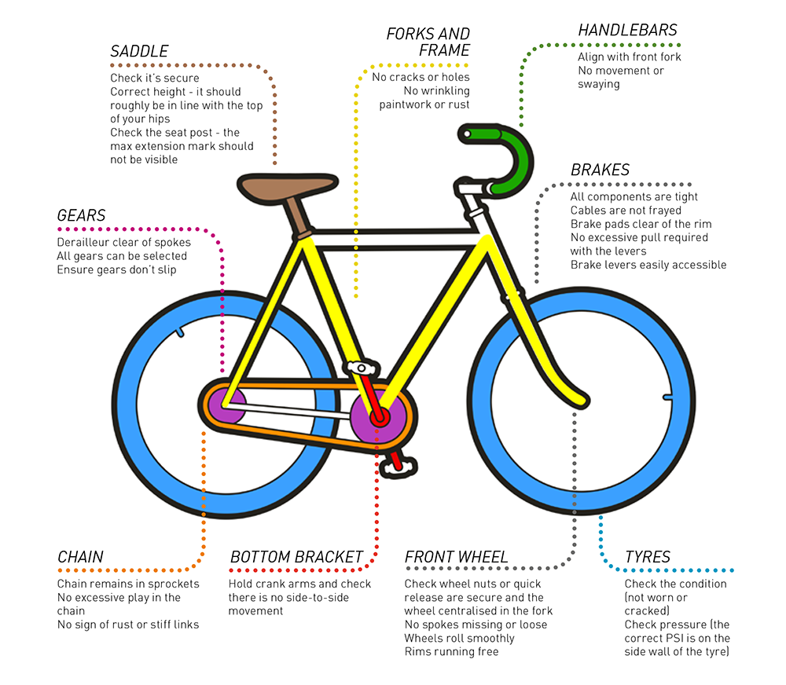

https://rideonmagazine.com.au/ride-ready-the-m-check/

Transporting your E-bike
Electric bikes are heavier than ordinary bikes. The battery plus motor add substantially to the weight of the bike and this must be taken into consideration when moving, lifting, and transporting the bike.
Before taking a bike from the Bothy think about when and how you will use the E-bike, and if there are any barriers like stairs at home, work, or wherever you plan to use the E-bike. Even getting them on and off buses requires a little bit more effort.
Transporting the E-bike by car
Usually an E-bike will not fit in your car fully assembled. You may need to remove a wheel and battery.
We don’t recommend you use a roof-rack to carry your E-bike. Lifting it on and off will be very strenuous and the bike may be heavier than the roof-rack’s maximum load. The same will apply to rear racks that are anchored by straps to the car boot. Tow-bar mounted racks can be stronger and easier to mount an E-bike onto. If transporting the E-bike on the outside of your vehicle, it is your responsibility to make sure the rack is strong enough to support it and that the E-bike is safely secured.
Removing the front wheel
The simplest way to get the E-bike into the car is to remove the front wheel. Undo the quick release and loosen the bolt on the other side. Carefully lift the front end of the E-bike whilst holding the wheel and it should pop out. If it does not, please check that the quick release is loose enough to disengage the hub from the security tabs on fork dropouts (where the wheel hub mounts into the fork).
A few important points if the bike has a disc brake:
- Never touch the metal rotor. Oils from your skin can contaminate the disc rotor and brake pads.
- Never put any weight on the rotor when it’s in your car as this may bend it out of shape and foul the brake calliper when the wheel is placed back in the fork.
- Never allow oil to get on the pads or rotor.
- Never touch the front brake lever (right hand brake lever) when the wheel has been removed - doing so causes the brake callipers to seize closed and you won’t be able to mount the wheel back into the fork. Bear this in mind when moving the bike in and out the car, and don’t put anything on top of the bike that may press the lever.
- Load the E-bike into the car, taking care not to bend or apply pressure to the mudguards (where applicable) which may cause them to rub against the tyre when cycling the E-bike.
Putting the wheel back on
- Holding the wheel upright carefully lower the E-bike’s fork onto the wheel, taking care to align the brake rotor between the calliper’s brake pads. Gently lower the fork onto the wheel hub.
- The wheel axle must be fully sat in the fork’s dropouts, otherwise it will not run straight; braking and safety will be severely compromised.
- To tighten the quick release, tighten the bolt on the opposite side of the wheel. The quick release lever should feel tight halfway through closing, otherwise the front wheel will be too loose and could fall out.
- Lift the front wheel and spin it- listen for any wear noises and look for any ‘wobble’ in the wheel. If either occur remove and replace the wheel.

